**Pattern Exercise : Problem 1**

#!/bin/bash -x

echo "Enter word "

read name

echo "Enter Last Name"

read LastName

echo "Enter Email"

read Email

echo "Enter Mobile Number"

read Mobile

echo "Enter Password"

read Password

Pattern1="^[A-z]{1}[a-zA-Z]*$"

Pattern2="^[A-z]{1}[a-zA-Z]*$"

Pattern3="^[a-z]{3}\.[a-z]*\@(bl)?\.(co)?[\.a-z]*$"

Pattern4= "^(\+91)?[6-9]{1}[0-9]{9}$"

Pattern5 = "^((?=.*\d)(?=.*[a-z])(?=.*[A-Z])(?=.*[@#$%]).{,20})$"

if [[$name =~ $Pattern1 -a $LastName =~ $Pattern2 -a $Email =~ $Pattern3 -a $Mobile =~ $Pattern4 -a $Password =~ $Pattern5 ]];

then

echo valid;

else

echo Invalid;

fi

**Problem 2:**

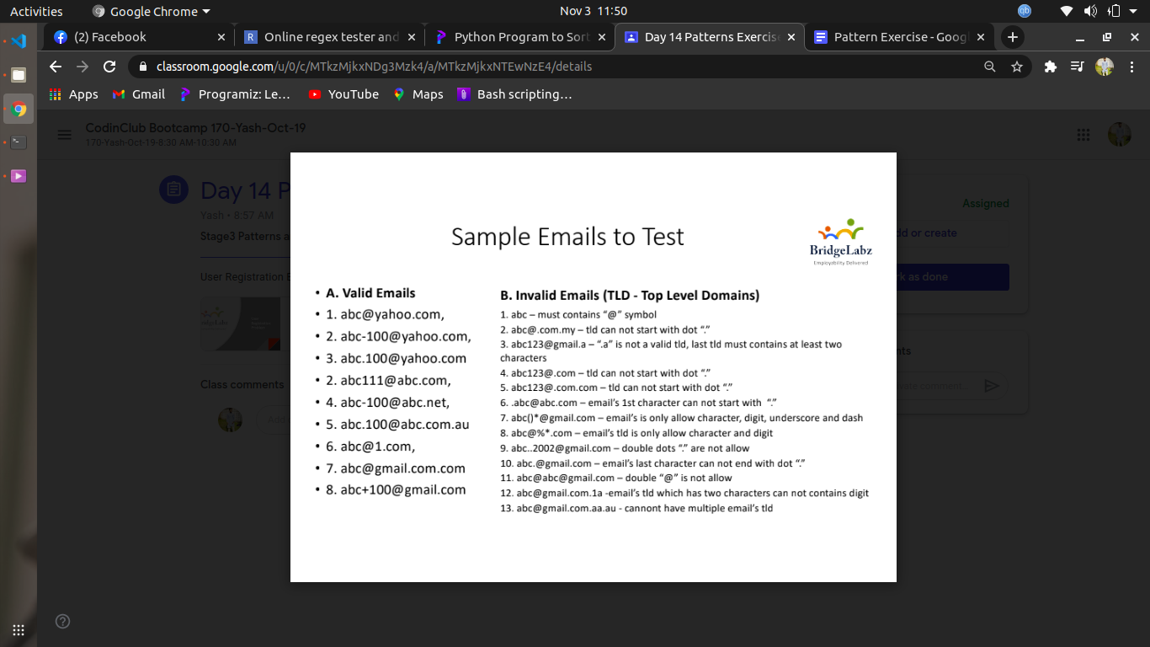

**For case 1, 2, 3, 6, 8 :**

#!/bin/bash -x

echo "Enter word "

read word

pat="^[a-z]{3}[0-9\+\.\_\-]*\@[0-9a-z]*\.(com|net)$"

if [[$word =- $pat ]];

then

echo valid;

else

echo Invalid;

fi

**For Q4, 5 & 7 :**

#!/bin/bash -x

echo "Enter word "

read word

pat="^[a-z]{3}[0-9\+\.\_\-]*\@[0-9a-z]*\.(com|net)\.(com|au)$"

if [[$word =- $pat ]];

then

echo valid;

else

echo Invalid;

fi